**Q2. Design and implement a Random Forest Classifier or Regressor model and explore the impact of hyperparameter tuning on model performance using scikit-learn, and evaluate its performance using various performance measures for a specific machine learning task.**

**Code:**

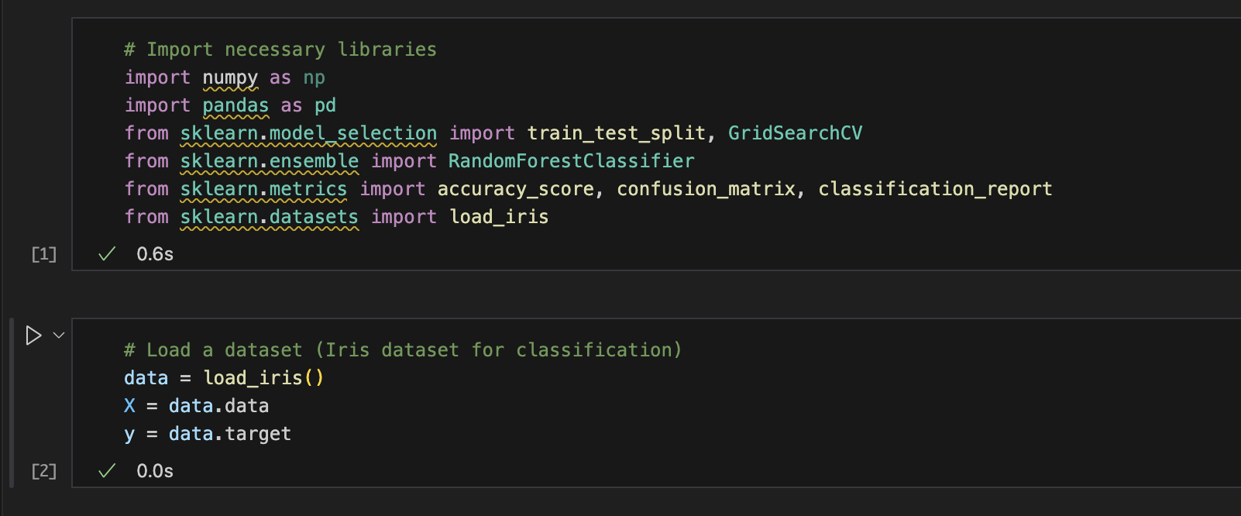

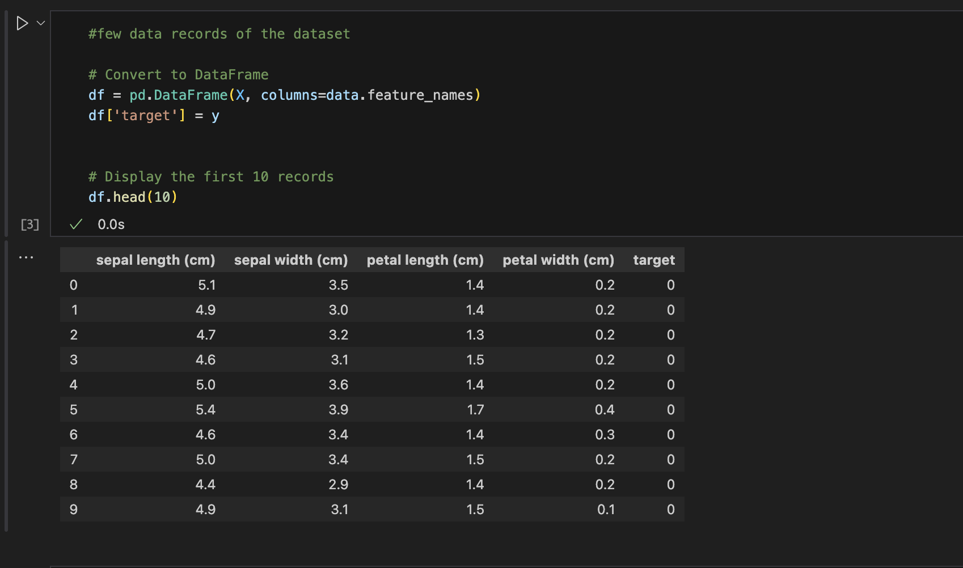

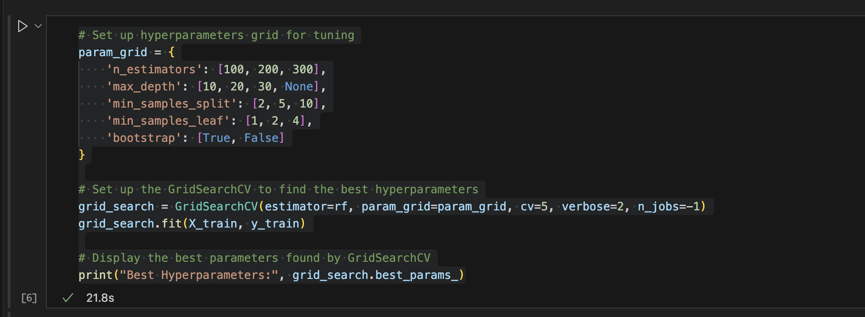

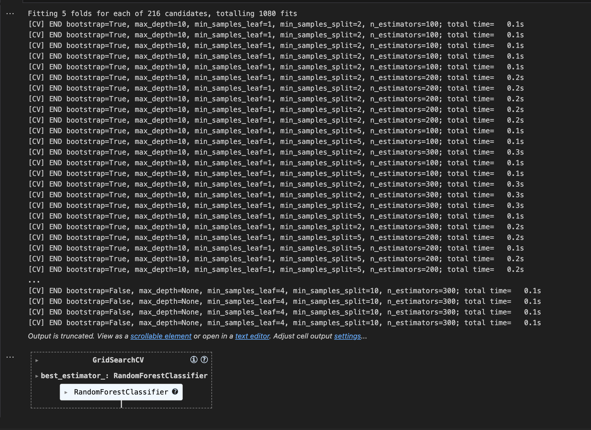

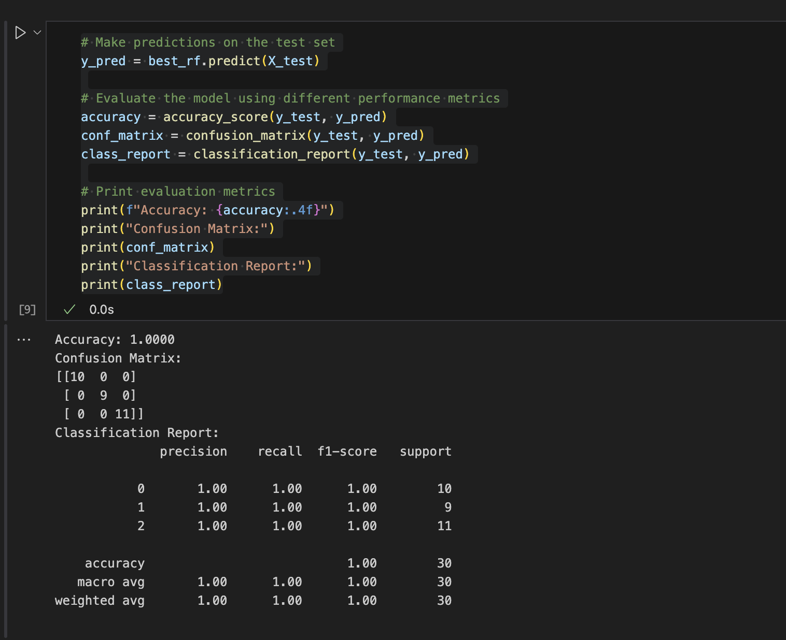

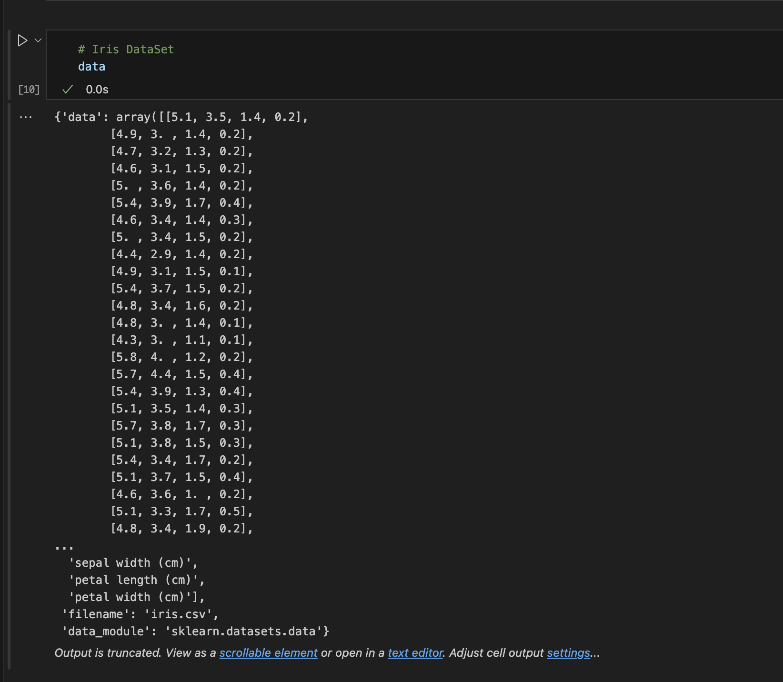

**Code As Text:**

**# Import necessary libraries**

import numpy as np

import pandas as pd

from sklearn.model_selection import train_test_split, GridSearchCV

from sklearn.ensemble import RandomForestClassifier

from sklearn.metrics import accuracy_score, confusion_matrix, classification_report

from sklearn.datasets import load_iris

**# Load a dataset (Iris dataset for classification)**

data = load_iris()

X = data.data

y = data.target

**#few data records of the dataset**

**# Convert to DataFrame**

df = pd.DataFrame(X, columns=data.feature_names)

df['target'] = y

**# Display the first 10 records**

df.head(10)

**# Split the data into training and testing sets (80% train, 20% test)**

X_train, X_test, y_train, y_test = train_test_split(X, y, test_size=0.2, random_state=42)

**# Initialize the Random Forest Classifier**

rf = RandomForestClassifier(random_state=42)

**# Set up hyperparameters grid for tuning**

param_grid = {

'n_estimators': [100, 200, 300],

'max_depth': [10, 20, 30, None],

'min_samples_split': [2, 5, 10],

'min_samples_leaf': [1, 2, 4],

'bootstrap': [True, False]

}

**# Set up the GridSearchCV to find the best hyperparameters**

grid_search = GridSearchCV(estimator=rf, param_grid=param_grid, cv=5, verbose=2, n_jobs=-1)

grid_search.fit(X_train, y_train)

**# Display the best parameters found by GridSearchCV**

print("Best Hyperparameters:", grid_search.best_params_)

**# Get the best estimator (model with tuned hyperparameters)**

best_rf = grid_search.best_estimator_

**# Train the model on the training data**

best_rf.fit(X_train, y_train)

**# Make predictions on the test set**

y_pred = best_rf.predict(X_test)

**# Evaluate the model using different performance metrics**

accuracy = accuracy_score(y_test, y_pred)

conf_matrix = confusion_matrix(y_test, y_pred)

class_report = classification_report(y_test, y_pred)

**# Print evaluation metrics**

print(f"Accuracy: {accuracy:.4f}")

print("Confusion Matrix:")

print(conf_matrix)

print("Classification Report:")

print(class_report)

